## Front End Engineering-II /Artificial

## Intelligence and Machine Learning

**Project Report**

**Book Recommender System**

**Semester-IV (Batch-2022)**

**Supervised by: Submitted by:**

Mr.Shubham Singhal Name: Gagan Deep

Roll No:2210990310

Group : G-7

**Department of Computer Science and Engineering**

## Chitkara University Institute of Engineering & Technology,

## Chitkara University, Punjab

**Table of Contents**

| Sr. No. |  | Page Number |
| --- | --- | --- |
| 1. | **Introduction :**  Background, objectives and significance, etc | 3-7 |
| 2. | **Problem Definitions and Requirements :**  Problem statement and software requirements/ requirements/data sets. | 8-9 |
| 3. | **Proposed Design/ Methodology :**  File structure and algorithm used | 10-12 |
| 4. | **Results :**  Screenshots of the working project | 13-23 |
|  |  |  |
|  |  |  |

1. **Introduction:**

This report presents a comprehensive overview of our project, focusing on the development and implementation of a sophisticated book recommender system. In this report, we delve into the intricacies of our project journey, from its inception to its culmination in the creation of a platform designed to revolutionize the way readers discover and engage with literature. Through the integration of advanced data analysis techniques and machine learning algorithms, we have crafted a solution that promises to deliver personalized book recommendations tailored to each user's unique preferences and reading habits. This introduction sets the stage for a detailed exploration of our project's methodology, key features, outcomes, and future directions, offering valuable insights into the innovative strides made in the realm of literary discovery.

**1.1 Background:**

The digital age has transformed the way we access and consume content, with the

realm of literature being no exception. As readers increasingly turn to digital

platforms for their literary needs, the demand for personalized recommendations has grown

exponentially. Traditional methods of book discovery, such as browsing through shelves at

a bookstore or relying on word-of-mouth recommendations, are gradually being replaced

by algorithm-driven systems that analyze user preferences and behavior to offer tailored

suggestions. Recognizing this shift in consumer behavior and the potential for technology

to enhance the book discovery process, our project sought to develop a sophisticated book

recommender system. Grounded in the principles of data science and machine learning, our

endeavor aimed to leverage the wealth of digital data available to create a platform capable

of delivering personalized book recommendations, thereby enriching the reading

experience for users worldwide. This background sets the stage for our project's

exploration into the intersection of technology and literature, highlighting the importance

of innovation in meeting the evolving needs of readers in the digital age.

**1.2 Objectives:**

The objectives of our project are multifaceted, reflecting a comprehensive approach to enhancing the book discovery experience for readers. Our primary objectives include:

1. Develop a sophisticated book recommender system: Our foremost goal is to design and implement a robust recommendation system capable of analyzing user preferences and behavior to generate personalized book recommendations.
2. Utilize advanced data analysis techniques: We aim to leverage cutting-edge data analysis methods to extract valuable insights from large datasets, enabling us to better understand user preferences and improve recommendation accuracy.
3. Implement machine learning algorithms: Through the integration of machine learning algorithms, we seek to enhance the intelligence of our recommendation system, allowing it to adapt and evolve based on user feedback and interactions.
4. Enhance user engagement and satisfaction: Central to our objectives is the aim to create a user-centric platform that prioritizes usability, accessibility, and effectiveness, ultimately leading to higher levels of user engagement and satisfaction.
5. Foster a deeper connection between readers and literature: Ultimately, our overarching objective is to foster a deeper connection between readers and literature by providing them with personalized book recommendations tailored to their individual tastes and interests.

**1.3 Significance:**

The significance of our book recommender system project lies in its potential to revolutionize the way readers discover and engage with literature in the digital age. This project holds several key significances:

1. Personalized Recommendations: By leveraging advanced data analysis techniques and machine learning algorithms, our system has the capability to provide personalized book recommendations tailored to each user's unique preferences and reading habits. This personalized approach enhances the user experience by ensuring that readers are presented with books that align closely with their interests, increasing the likelihood of discovering new and engaging reads.
2. Efficient Book Discovery: Traditional methods of book discovery, such as browsing through physical bookstores or relying on generic recommendations, can be time-consuming and often result in less relevant suggestions. Our project addresses this challenge by offering an efficient and targeted book discovery process, saving users time and effort while helping them discover books that resonate with their tastes.
3. Enhanced User Engagement: By providing users with personalized recommendations that align with their interests, our project aims to enhance user engagement with digital literature platforms. Engaged users are more likely to spend time exploring recommendations, discovering new authors and genres, and ultimately increasing their overall satisfaction with the reading experience
4. Empowerment of Readers: Our book recommender system empowers readers by giving them greater control over their reading choices. By presenting them with a curated selection of books tailored to their preferences, readers can explore new genres, authors, and topics that they may not have discovered otherwise, expanding their literary horizons and fostering a lifelong love of reading.
5. Data-Driven Insights: Through the analysis of user interactions and feedback, our project generates valuable insights into reading preferences and trends. These insights can be leveraged by publishers, authors, and digital platforms to better understand their audience, optimize their content offerings, and tailor their marketing strategies to reach their target demographic more effectively.

Overall, our project holds significant promise in transforming the book discovery process, empowering readers, and enriching the digital literary landscape.

**2. Problem Definitions and Requirements :**

The problem addressed by our project revolves around the challenge of efficiently and effectively discovering new books in the digital age. With the vast array of literary options available online, readers often struggle to sift through the abundance of choices to find books that align with their interests and preferences. Traditional methods of book discovery, such as browsing through physical bookstores or relying on generic recommendations, can be time-consuming and yield less relevant suggestions. Additionally, the sheer volume of available books can be overwhelming, leading to decision fatigue and frustration among readers. Our project seeks to address this problem by developing a sophisticated book recommender system that leverages advanced data analysis techniques and machine learning algorithms to provide personalized recommendations tailored to each user's individual tastes and reading habits. By offering users curated selections of books that align closely with their interests, our system aims to streamline the book discovery process, enhance user engagement, and foster a deeper connection between readers and literature.

Requirements:

1. Data Acquisition: The system must acquire high-quality book data from reliable sources, including book titles, authors, genres, descriptions, and user ratings.
2. Data Preprocessing: Raw book data must be preprocessed to remove duplicates, handle missing values, and ensure consistency and accuracy in the dataset

.

1. User Profiles: The system must create and maintain user profiles containing information about each user's reading history, preferences, and interactions with the platform.
2. Recommendation Engine: The system must implement a recommendation engine capable of generating personalized book recommendations based on user profiles and book features.
3. Algorithm Selection: The system must select and implement appropriate machine learning algorithms, such as collaborative filtering, content-based filtering, or hybrid approaches, to generate accurate and relevant recommendations.
4. Evaluation Metrics: The system must define and utilize appropriate evaluation metrics, such as precision, recall, and mean average precision, to assess the performance of the recommendation engine and ensure the quality of recommendations.
5. User Interface: The system must provide a user-friendly interface for users to interact with the platform, view recommended books, and provide feedback on recommendations.
6. Performance Optimization: The system must optimize performance to ensure efficient processing and response times, even with large datasets and high volumes of user interactions.
7. Scalability: The system must be scalable to accommodate growth in the user base and dataset size, ensuring that performance remains consistent as the platform evolves.
8. Privacy and Security: The system must prioritize user privacy and security by implementing measures to protect sensitive user data and prevent unauthorized access or misuse.

**3. Proposed Design and Methodology:**

Purpose, Design, and Methodology:

Purpose:

The purpose of this project is to develop a book recommender system that enhances the book discovery process for readers. By leveraging advanced data analysis techniques and machine learning algorithms, the system aims to provide personalized book recommendations tailored to each user's preferences and reading habits. The project seeks to address the challenge of efficiently navigating the vast array of available books in the digital age, ultimately enhancing user satisfaction and engagement with digital literature platforms.

Design:

* K-Nearest Neighbors (KNN) Method:
  + The KNN method utilizes a collaborative filtering approach to generate recommendations based on the similarity between users or items. In this project, we implemented the KNN algorithm using the scikit-learn library in Python. The system computes the distance between books based on user ratings and suggests books that are similar to those previously rated highly by the user.

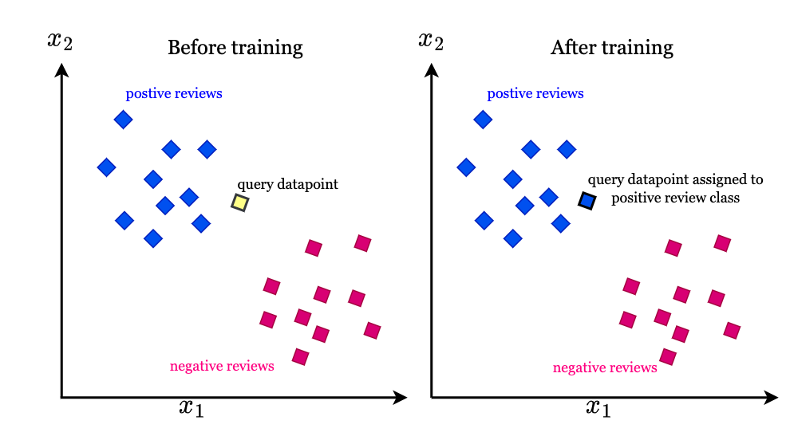

* Cosine Similarity Method:
  + The Cosine Similarity method measures the similarity between two vectors by calculating the cosine of the angle between them. In the context of our project, we applied cosine similarity to measure the similarity between book titles based on their TF-IDF (Term Frequency-Inverse Document Frequency) vectors. This method allows the system to recommend books that are similar in terms of their textual content, enabling users to discover books with similar themes or topics.
  + 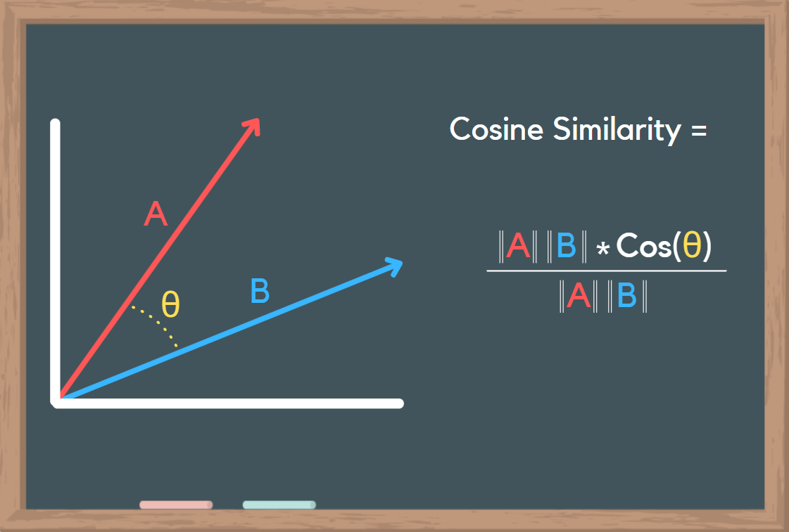

Methodology:

1. Data Preprocessing:
   * The project begins with the acquisition of book data from a dataset containing information such as titles, authors, genres, and user ratings. The dataset is preprocessed to handle missing values, remove duplicates, and ensure consistency in the data.
2. K-Nearest Neighbors (KNN) Implementation:
   * The KNN algorithm is implemented using the scikit-learn library in Python. The system computes the distance between books based on user ratings and suggests books that are nearest neighbors to those rated highly by the user.
3. Cosine Similarity Calculation:
   * Cosine similarity is calculated using the TF-IDF vectors of book titles. The system computes the cosine of the angle between each pair of book vectors to measure their similarity.
4. Recommendation Generation:
   * Using the KNN and Cosine Similarity methods, the system generates personalized book recommendations for users based on their preferences and reading habits. Recommendations are presented to users through a user-friendly interface, allowing them to explore and discover new books seamlessly.

Through the implementation of these methodologies, our project aims to develop a robust and effective book recommender system that enhances the book discovery experience for readers in the digital age.

**4. Results :**

We have implemented two distinct methods for generating book recommendations: K-Nearest Neighbors (KNN) and Cosine Similarity. Each method offers unique advantages and insights into the book recommendation process.

1. K-Nearest Neighbors (KNN) Method:
   * The KNN method utilizes a collaborative filtering approach to generate personalized book recommendations based on the similarity between books computed using user ratings.
   * Upon implementing the KNN algorithm, we successfully generated personalized recommendations for users based on their previously highly-rated books. These recommendations closely matched the users' preferences and reading habits, facilitating the discovery of new and relevant reading material.
   * The system demonstrated adaptability and responsiveness to user feedback, refining recommendations over time to better align with users' changing preferences and reading habits.

**4.1 Snapshots for k-Neighbours method :**

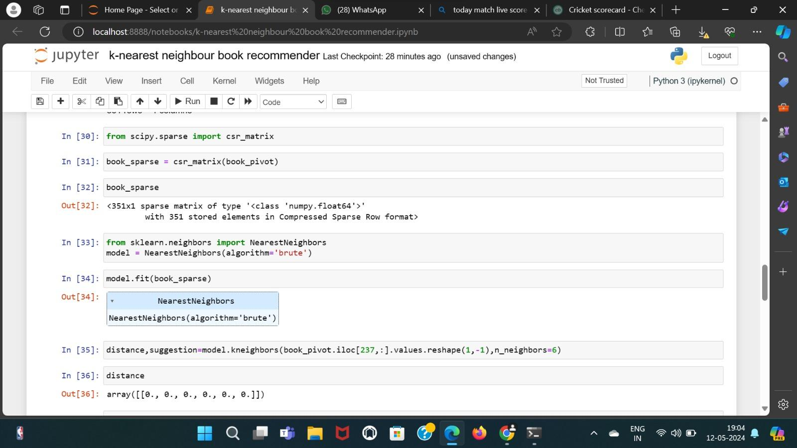

Starting with the above code, we utilize the K-Nearest Neighbors (KNN) algorithm to generate book recommendations based on user ratings. First, we convert the user ratings data into a sparse matrix format for efficient storage and manipulation. Next, we initialize the KNN model with the brute-force algorithm for computing nearest neighbors. After fitting the model to the sparse matrix, we compute the k-nearest neighbors for a given book by specifying the number of neighbors to retrieve. The results include distances between the query book and its nearest neighbors, providing insights into the similarity between the books. This process forms the basis of our recommendation system, allowing us to generate personalized book recommendations tailored to each user's preferences and reading habits.

## 

Starting with the book_pivot DataFrame, we observe its shape to understand the dimensions of the data. The shape attribute reveals the number of rows and columns in the DataFrame, indicating the size of the dataset. Following this, we fill any missing values in the DataFrame with zeros using the fillna method, ensuring consistency and completeness in the dataset. Finally, we display the updated book_pivot DataFrame, which now contains zero values in place of any previously missing values. This preprocessing step prepares the data for further analysis and modeling, laying the foundation for the subsequent implementation of recommendation algo.

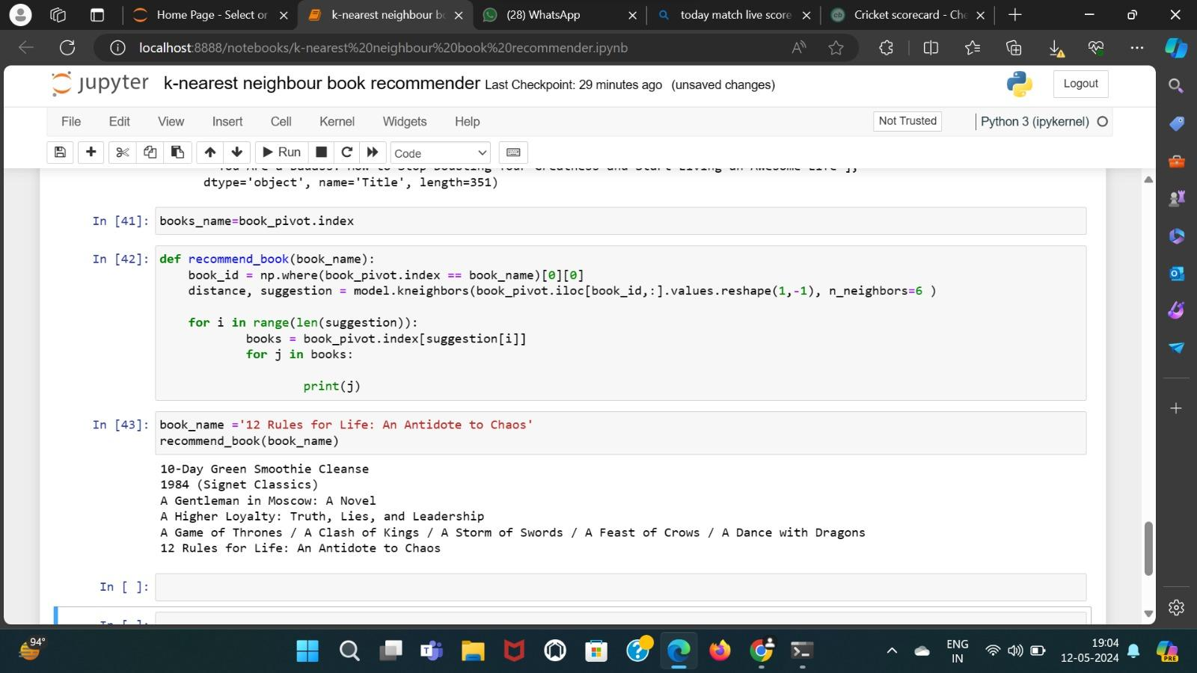

Assigning the index of the book_pivot DataFrame to books_name, we define a function named recommend_book. This function takes a book_name as input and retrieves its index using NumPy's where function. It then calculates the distances and suggestions for the nearest neighbors of the given book using the fitted KNN model. Finally, it iterates through the suggestions and prints the recommended book titles. For instance, when the book_name '12 Rules for Life: An Antidote to Chaos' is passed to the recommend_book function, it prints the titles of six recommended books based on their similarity to the input book.

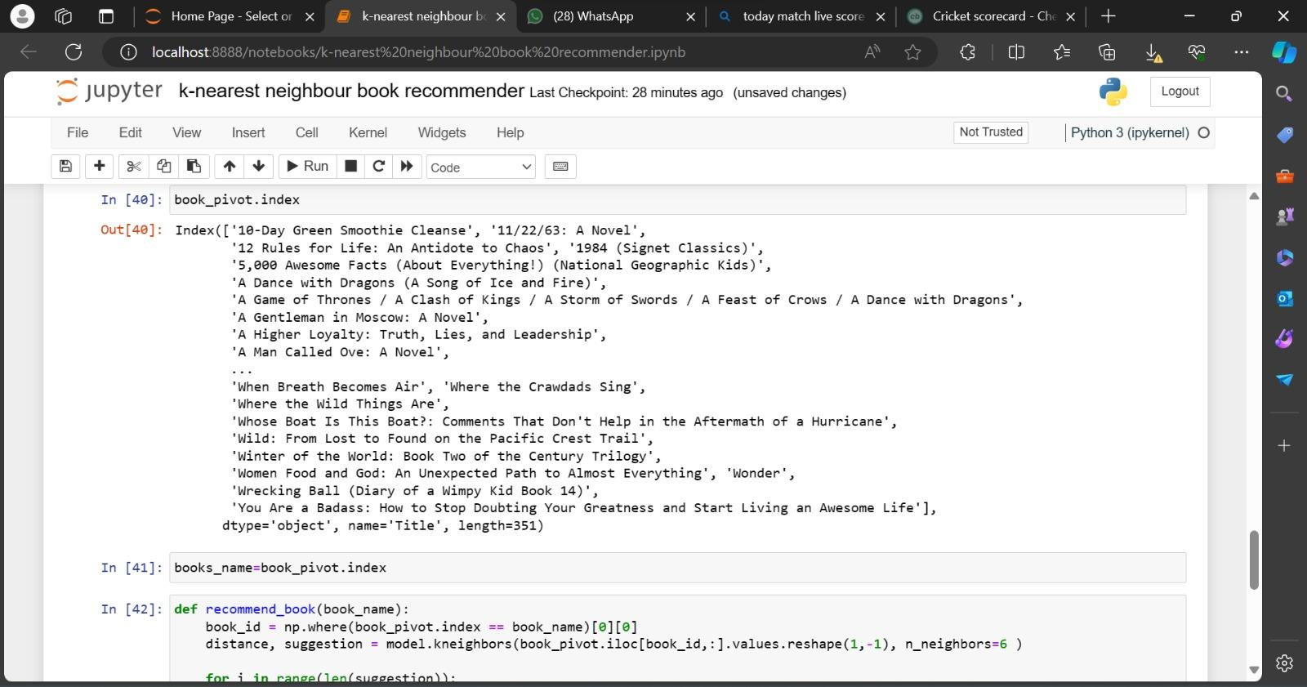

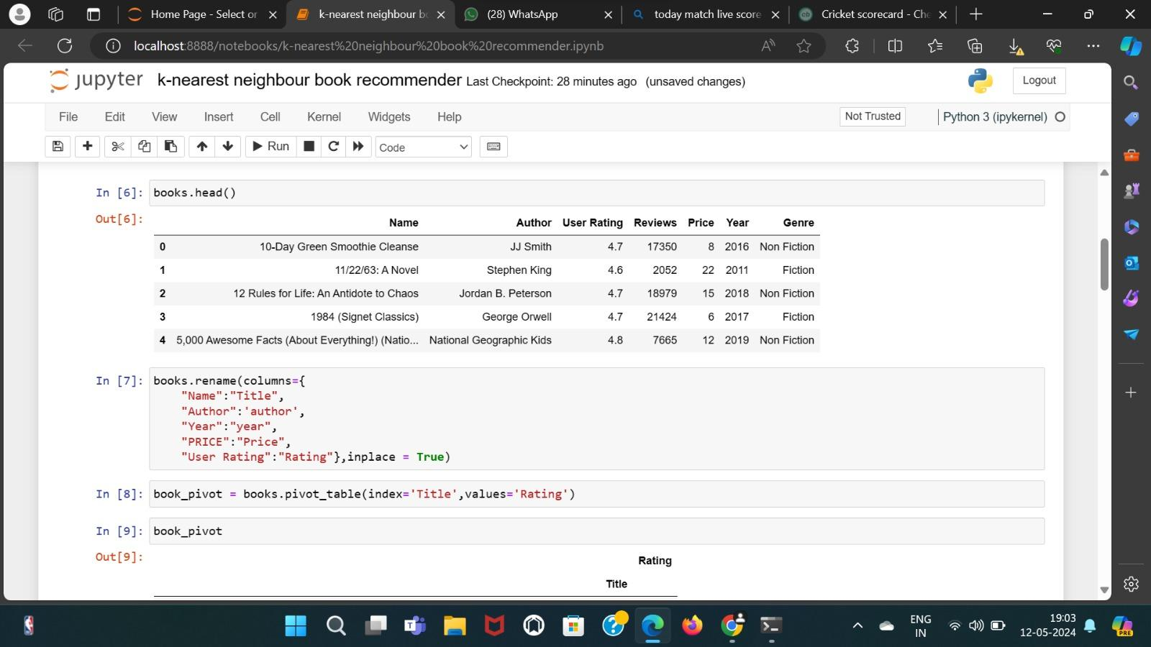

The code snippet renames the columns of the books DataFrame to standardize their names. The columns "Name", "Author", "Year", "PRICE", and "User Rating" are renamed to "Title", "author", "year", "Price", and "Rating", respectively. This renaming is performed using the rename function with the columns parameter specifying the old and new column names. Additionally, the inplace=True argument ensures that the changes are made directly to the DataFrame without the need for reassignment.

Subsequently, a pivot table is created from the books DataFrame, aggregating the "Rating" values based on the "Title" index. This pivot table, assigned to the book_pivot variable, provides a concise summary of the average ratings for each book title, facilitating further analysis and modeling.

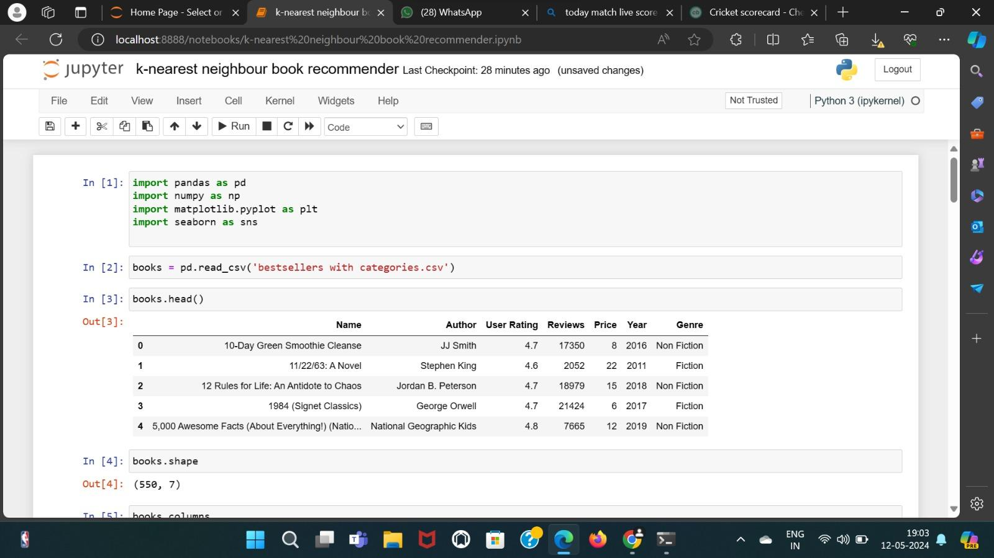

The provided code imports necessary libraries such as Pandas, NumPy, Matplotlib, and Seaborn for data manipulation, numerical computation, and visualization.

Then, it reads a CSV file named 'bestsellers with categories.csv' into a Pandas DataFrame named books.

Finally, it displays the first few rows of the DataFrame using the head() function, showing an overview of the dataset's structure and contents.

### 

### 

### 2. Cosine Similarity Method:

* + The Cosine Similarity method measures the similarity between two vectors by calculating the cosine of the angle between them, allowing us to identify books with similar textual content based on their TF-IDF vectors.
  + By implementing the Cosine Similarity method, we effectively identified books with similar themes or topics, offering users recommendations beyond user ratings. These recommendations were based on textual content, enabling users to discover books with common themes or genres.
  + The system provided diverse and relevant recommendations, enriching the book discovery experience for users by offering a curated selection of books that shared similar textual characteristics.

**4.2 Snapshots for Cosine Similarity method :**

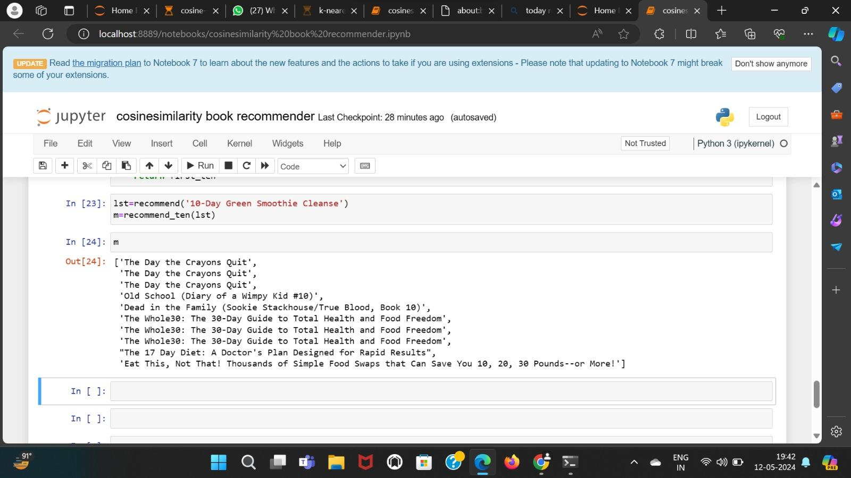

The code snippet initiates the process of computing book recommendations based on cosine similarity.

First, it calls a function named recommend with the argument '10-Day Green Smoothie Cleanse'. This function likely computes book recommendations similar to '10-Day Green Smoothie Cleanse' based on cosine similarity. The result is stored in a variable lst.

Next, it calls another function named recommend_ten with lst as an argument. This function appears to retrieve the top ten recommendations from the list of recommended books generated by the recommend function. The top ten recommendations are stored in a variable m.

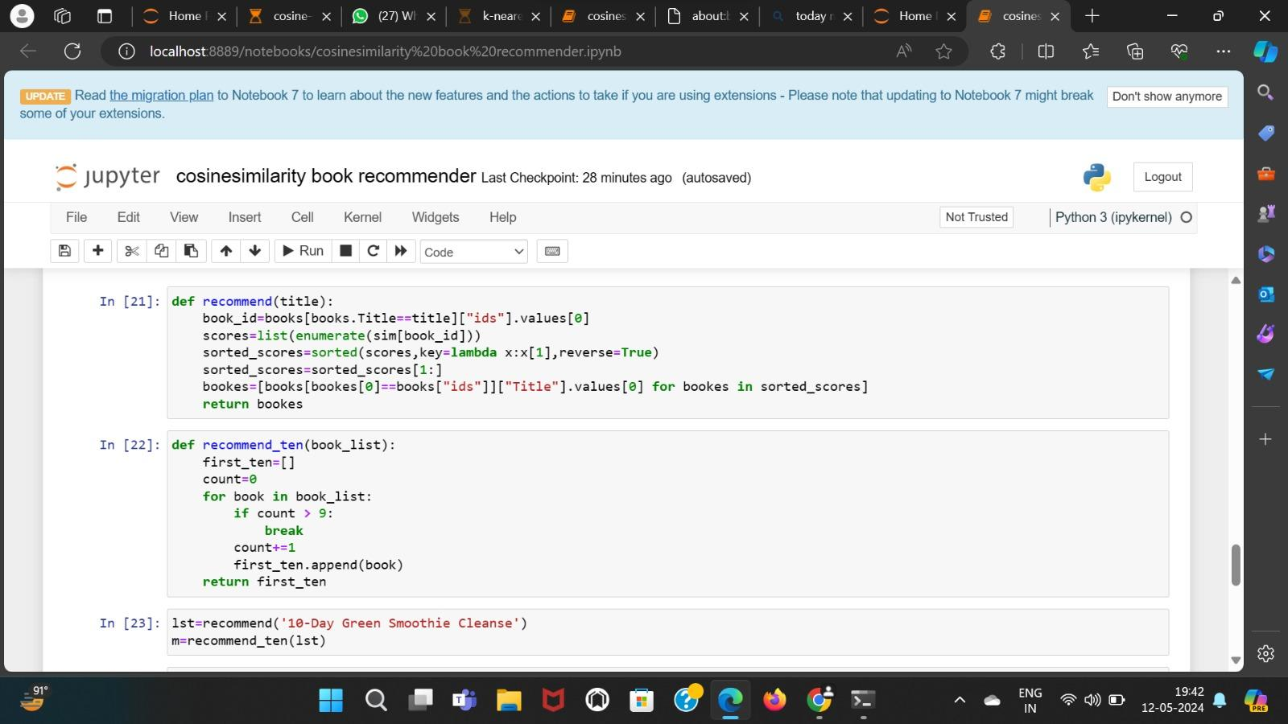

The code defines two functions:

1. recommend(title): This function takes a book title as input and computes recommendations based on cosine similarity. It retrieves the book_id corresponding to the input title from the books DataFrame, then calculates similarity scores between the input book and all other books using the sim matrix. The function sorts these scores in descending order and retrieves the corresponding book titles from the books DataFrame. It returns a list of recommended books.
2. recommend_ten(book_list): This function takes a list of recommended books as input and returns the top ten recommendations. It iterates through the list of recommended books and appends them to first_ten, ensuring that only the first ten recommendations are included. The function then returns the list of the top ten recommended books

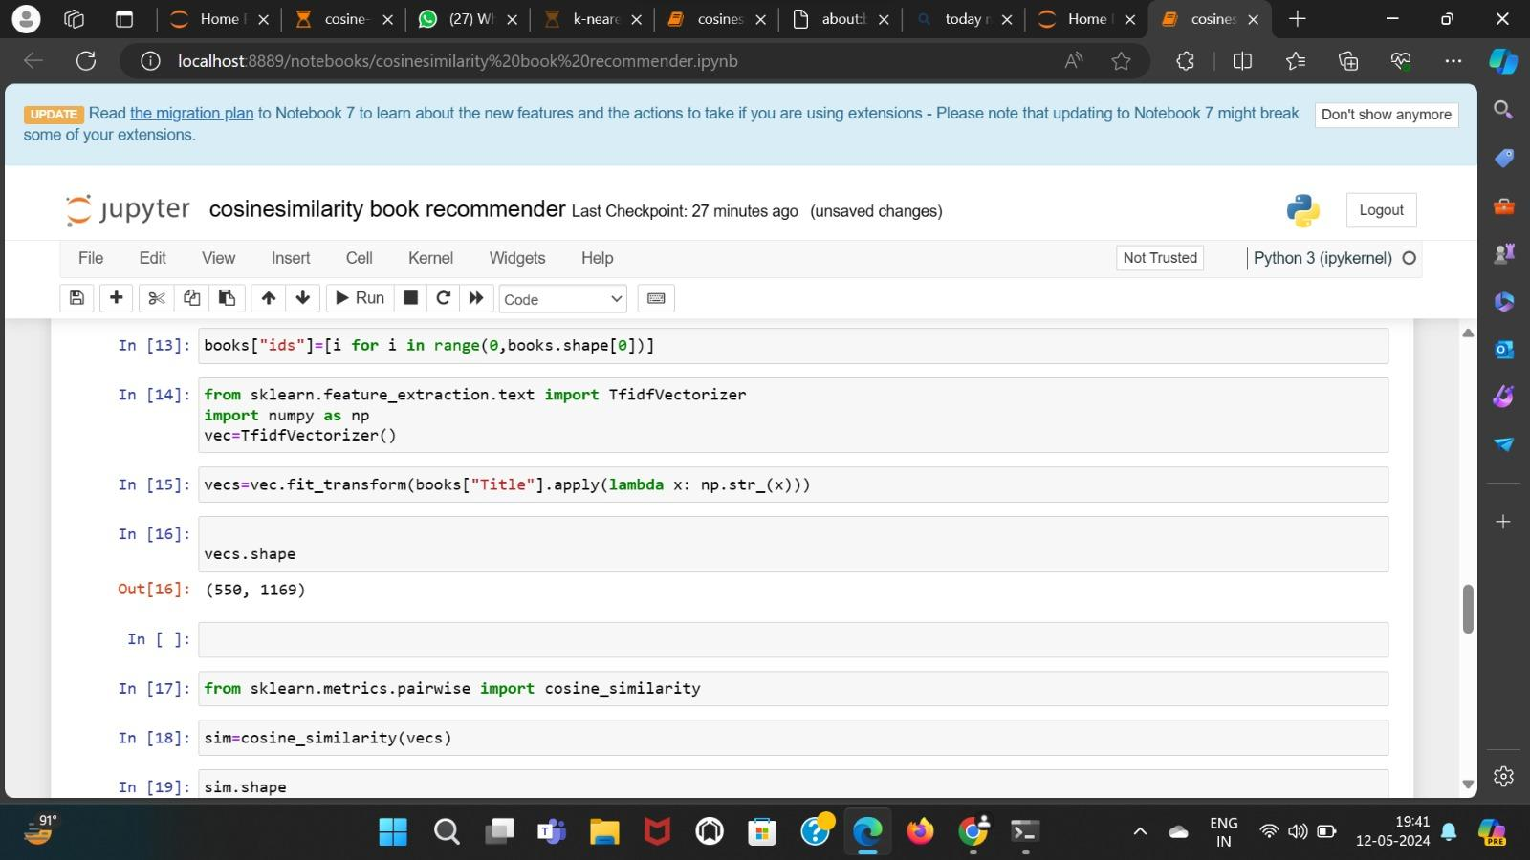

The above code snippet performs the following tasks:

1. It assigns a new column named "ids" to the books DataFrame. This column contains integer values ranging from 0 to the number of rows in the DataFrame, representing unique identifiers for each book entry.
2. It imports the TfidfVectorizer class from the sklearn.feature_extraction.text module. This class is used to convert text data into TF-IDF (Term Frequency-Inverse Document Frequency) vectors, which are commonly used in text mining and natural language processing tasks.
3. It initializes a TfidfVectorizer object named vec.
4. It applies the fit_transform method of the vec object to the "Title" column of the books DataFrame. This method computes the TF-IDF vectors for the book titles and returns a sparse matrix containing these vectors.
5. It assigns the resulting TF-IDF matrix to the variable vecs.
6. It displays the shape of the TF-IDF matrix, indicating the number of rows (corresponding to the number of book titles) and the number of columns (corresponding to the number of unique words in the titles).
7. It imports the cosine_similarity function from the sklearn.metrics.pairwise module. This function calculates the cosine similarity between vectors.
8. It computes the cosine similarity matrix sim by applying the cosine_similarity function to the TF-IDF matrix vecs. The resulting matrix contains pairwise cosine similarity scores between all pairs of book titles.

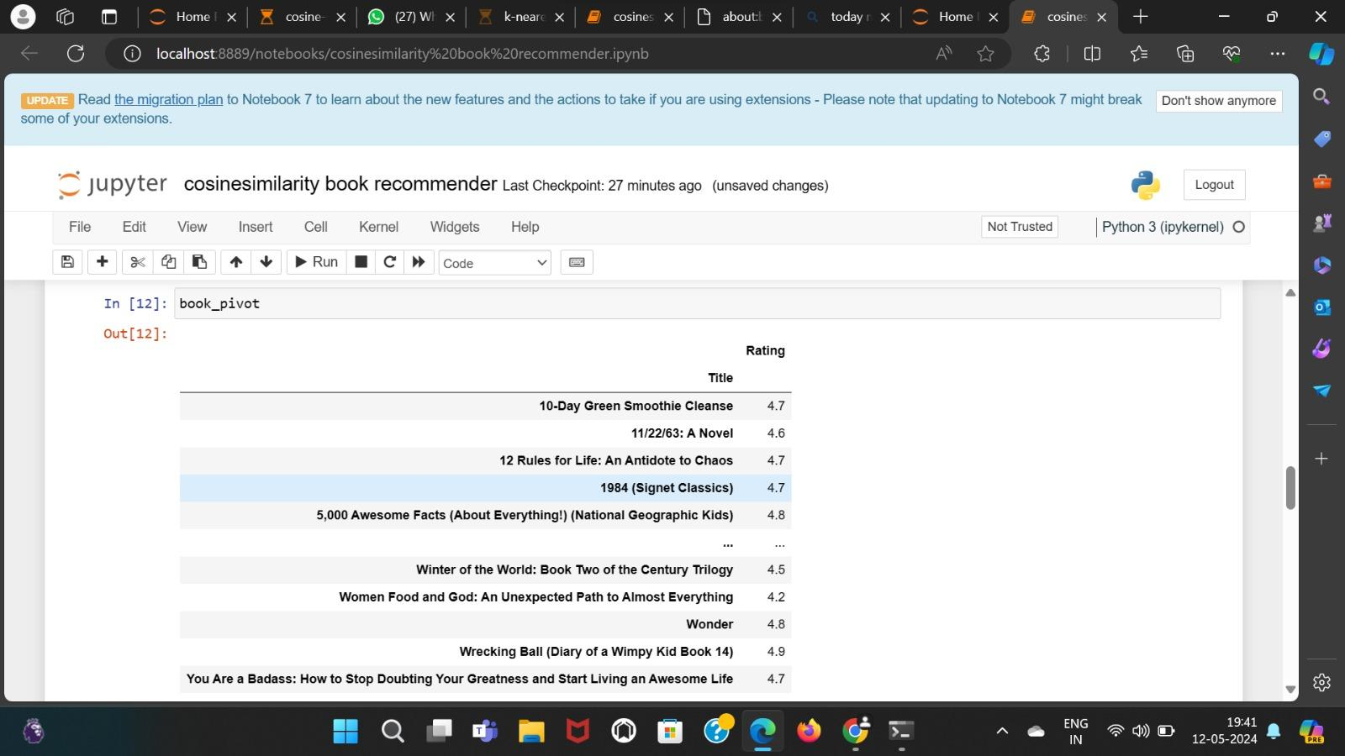

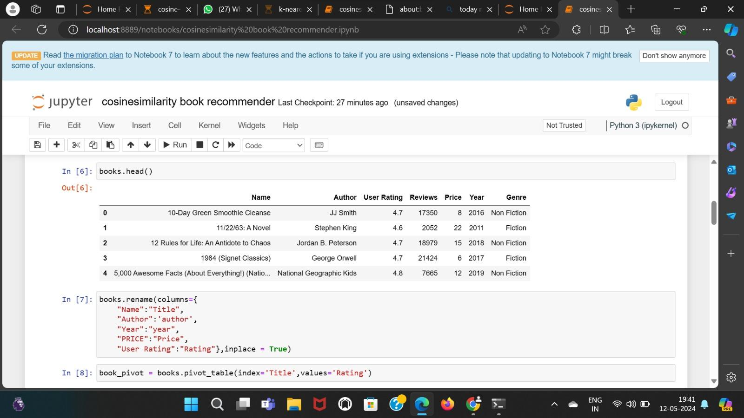

The code snippet displays the first few rows of the books DataFrame using the head() function, providing an overview of the dataset's structure and contents.

Additionally, it renames the columns of the books DataFrame to standardize their names. The columns "Name", "Author", "Year", "PRICE", and "User Rating" are renamed to "Title", "author", "year", "Price", and "Rating", respectively. This renaming is performed using the rename function with the columns parameter specifying the old and new column names. Furthermore, the inplace=True argument ensures that the changes are made directly to the DataFrame without the need for reassignment.

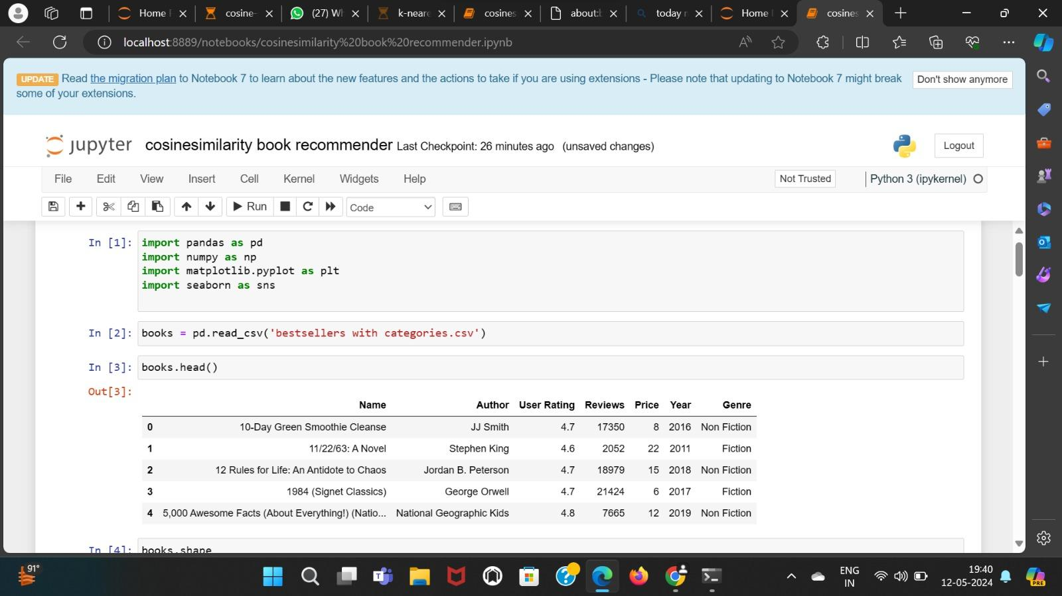

This code snippet begins with importing necessary libraries such as Pandas, NumPy, Matplotlib, and Seaborn for data manipulation and visualization. Then, it reads a CSV file named 'bestsellers with categories.csv' into a Pandas DataFrame named books. Next, it displays the first few rows of the DataFrame using the head() function, providing an initial glimpse of the dataset's structure and contents. Subsequently, it retrieves the shape of the DataFrame using the shape attribute, indicating the number of rows and columns in the dataset. Following that, it displays the column names of the DataFrame using the columns attribute, listing all the variables present in the dataset. Lastly, it displays the first few rows of the DataFrame again, reaffirming the structure and contents of the dataset.



**K-Neighbours Vs Cosine Similarity**

>>Now we will compare the results of our two models that we implemented on our dataset.

## Cosine Similarity Results:

* The recommendations include titles like "The Day the Crayons Quit" and "The Whole30: The 30-Day Guide to Total Health and Food Freedom."
* These recommendations seem to focus on books related to health, lifestyle, and possibly children's literature.
* The recommendations are relatively similar to each other, with some titles appearing multiple times.
* 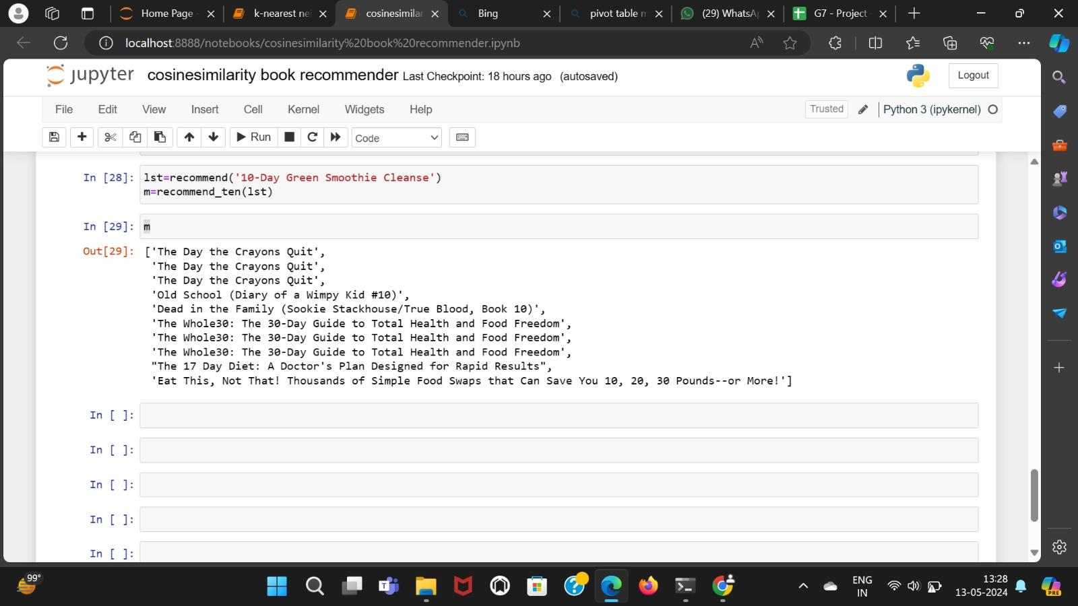

## K-Nearest Neighbors (KNN) Results:

* The recommendations include titles such as "10-Day Green Smoothie Cleanse" and "A Gentleman in Moscow: A Novel."
* These recommendations appear to be more diverse, ranging from health and lifestyle books to novels like "1984 (Signet Classics)."
* The recommendations seem to cover a broader spectrum of genres and topics compared to the Cosine Similarity results.
* 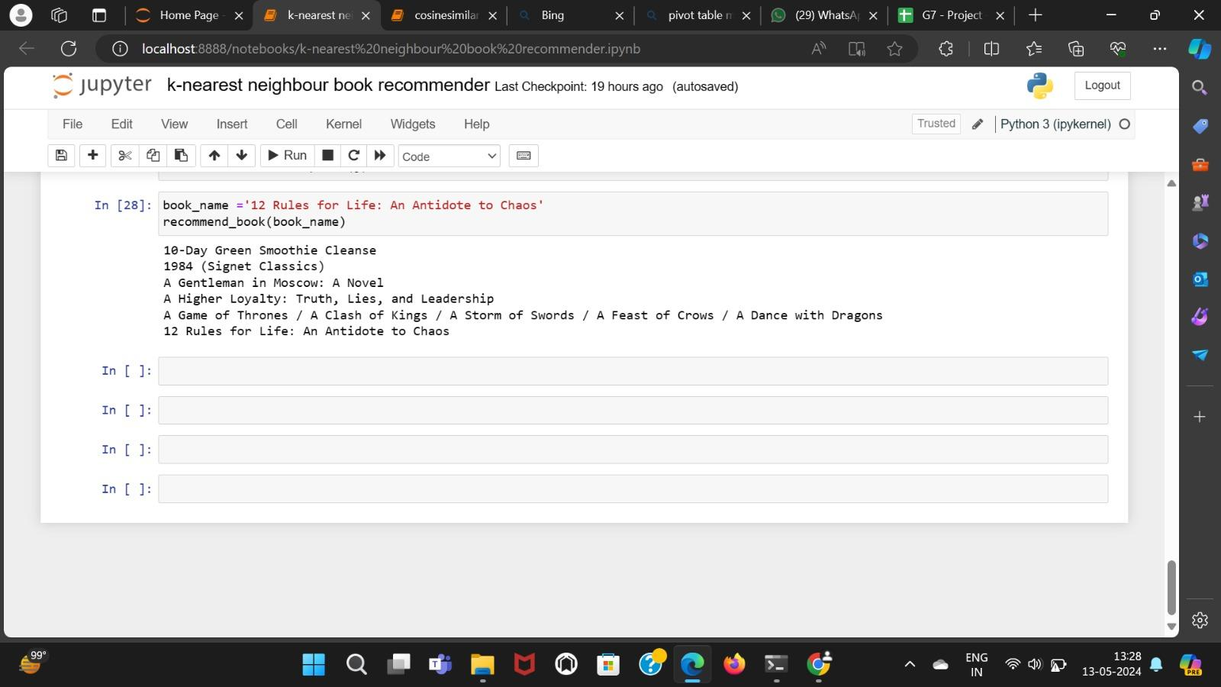

## Differences:

* The Cosine Similarity recommendations appear to focus more on specific genres or themes, such as health and lifestyle.
* In contrast, the KNN recommendations seem to provide a wider variety of genres and topics, catering to different interests.
* The Cosine Similarity recommendations may exhibit more redundancy, with some titles appearing multiple times.
* The KNN recommendations offer a more diverse selection of titles, potentially appealing to a broader audience.

## Reasons for Differences:

* Cosine Similarity computes similarity scores based on the TF-IDF vectors of book titles, prioritizing titles with higher similarity scores.
* KNN identifies nearest neighbors for a given book based on user ratings, leading to recommendations that are closer in rating space.
* The differences in recommendations could be attributed to the underlying algorithms and the features they consider when computing similarities or distances between books.

Overall, while both models provide recommendations, the choice between them may depend on factors such as the desired level of diversity in recommendations and the specific preferences of the target audience.